Kuujjuaq Maternity-Ungava Tulattavik Health Center
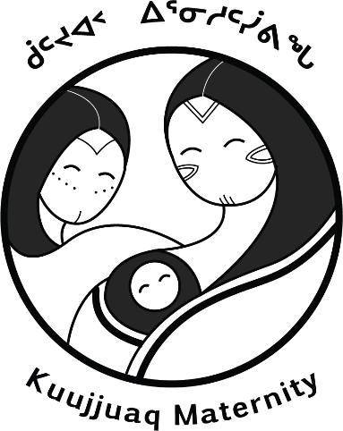
Our team is looking for part time and full time midwives to come work for periods of 2 to 8 weeks, 2 to 8 times a year.
We are a team of Inuit and non-Inuit midwives who are dedicated to training more Inuit midwives. We work in a small hospital in a remote community (no ER, no anesthesia), where midwives provide all prenatal care, as well as care during labor for low to medium risk pregnancies, with support from family doctors in cases of emergencies or higher risk pregnancies and births. We also participate in medical evacuations (by plane) from smaller communities, mostly for preterm labor and birth. Our common language of work is English, but a lot of charting at the hospital is in French, and Inuktitut is most of the population's first language.
Kuujjuaq is the biggest community in Nunavik, Quebec, home to about 3000 people. It’s a beautiful town, at the limit between taiga and toundra. The town is on the banks of the Koksoak River, 30 miles from the Ungava Bay. There are a few beautiful sand beaches, and plenty of beautiful hikes around town. During winter, cross-country ski, snow shoeing and ski-doo rides are some of the common activitie. Access to the gym is payed for hospital employees.
Conditions for all contracts:
- Salary: Min.: $1,503.29 to Max: $2133.68 / week
- Isolation premium: $203.66/week or more as per the family status
- High cost of living premium: $74.17/ week or more, according to family status
- Retention premium: 383.29$/Week
- Paid overtime
- Paid travel costs
- Furnished lodging provided by employer
Minimum Requirements:
- Current Obstetric Emergency Skills certification; (within 3 years)
- Updated Neonatal Resuscitation certification (including intubation); (2 years)
- Excellent communication and teaching skills
- Fluency in English
- Ability to speak and write Inuktitut or French is an asset but not required
- Northern and/or cross-cultural experience is an asset.
- Eligibility for registration with the OSFQ – reciprocity is available for midwives registered in other Canadian provinces or territories.

